Company Hierarchy Project
Project Setup (Hierarchy)
1.1. Create virtual environment and install Django & DRF
python -m venv env

env\Scripts\activate # Use source env/bin/activate on Linux

pip install django djangorestframework

1.2. Create a Django project
django-admin startproject CompanyProject

cd CompanyProject
1.3. Create the app
python manage.py startapp staff

1.4. Add to settings.py
# CompanyProject/settings.py
INSTALLED_APPS = [
...
'rest_framework',
'staff',
]
Step 2: Create Models
staff/models.py
from django.contrib.auth.models import AbstractUser
from django.db import models

class User(AbstractUser):
ROLE_CHOICES = [
('trainee', 'Trainee'),
('team_member', 'Team Member'),
('team_leader', 'Team Leader'),
('manager', 'Manager'),
]
role = models.CharField(max_length=20, choices=ROLE_CHOICES)

def __str__(self):
return f"{self.username} ({self.get_role_display()})"
Step 3: Configure Custom User Model
In settings.py:
AUTH_USER_MODEL = 'staff.User'

Step 4: Migrate & Create Superuser
python manage.py makemigrations
python manage.py migrate
python manage.py createsuperuser

Step 5: Serializers
staff/serializers.py
from rest_framework import serializers
from .models import User

class UserSerializer(serializers.ModelSerializer):
password = serializers.CharField(write_only=True)

class Meta:
model = User
fields = ['id', 'username', 'email', 'password', 'role']

def create(self, validated_data):
password = validated_data.pop('password')
user = User(**validated_data)
user.set_password(password)
if validated_data.pop('role') == 'trainee':
user.is_staff = False # To allow admin login if needed
else:
user.is_staff = True
user.save()
return user

Step 6: Permissions
staff/permissions.py
from rest_framework.permissions import BasePermission

class IsManager(BasePermission):
def has_permission(self, request, view):
return request.user.is_authenticated and request.user.role == 'manager'

class IsTeamLeaderOrManager(BasePermission):
def has_permission(self, request, view):
return request.user.is_authenticated and request.user.role in ['manager', 'team_leader']

Step 7: Views with CRUD
staff/views.py
from rest_framework import viewsets
from rest_framework import generics, permissions
from rest_framework.permissions import IsAuthenticated
from .models import User
from .serializers import UserSerializer
from .permissions import IsManager, IsTeamLeaderOrManager

class UserViewSet(viewsets.ModelViewSet):
queryset = User.objects.all()
serializer_class = UserSerializer

def get_permissions(self):
if self.action in ['create', 'destroy']:
permission_classes = [IsManager]
elif self.action in ['update', 'partial_update']:
permission_classes = [IsTeamLeaderOrManager]
else:
permission_classes = [IsAuthenticated]
return [permission() for permission in permission_classes]

class UserCreateAPIView(generics.CreateAPIView):
queryset = User.objects.all()
serializer_class = UserSerializer
permission_classes = [permissions.AllowAny] # Allow anyone to create users (change if needed)

Step 8: URLs
staff/urls.py
from rest_framework.routers import DefaultRouter
from .views import UserViewSet
from django.urls import path
from .views import UserCreateAPIView

router = DefaultRouter()
router.register(r'users', UserViewSet)

urlpatterns = router.urls

# from django.urls import path
# from .views import UserCreateAPIView

urlpatterns = [
path('api/users/', UserCreateAPIView.as_view(), name='user-create'),
]

CompanyProject/urls.py
from django.contrib import admin
from django.urls import path, include

urlpatterns = [
path('admin/', admin.site.urls),
path('api/', include('staff.urls')),
path('', include('staff.urls')),
]

Step 9: Authentication Setup
You can use DRF's built-in session authentication or token authentication.
Enable Session Auth in settings.py
REST_FRAMEWORK = {
'DEFAULT_AUTHENTICATION_CLASSES': [
'rest_framework.authentication.SessionAuthentication',
],
'DEFAULT_PERMISSION_CLASSES': [
'rest_framework.permissions.IsAuthenticated',
],
}
Step 10: Test
python manage.py runserver
Add Fixtures for Test Users
Start Shell:
python manage.py shell
Insert Full code:
Insert Test Users:
from staff.models import User

User.objects.create_user(username="trainee1", email="trainee1@example.com", password="pass123", role="trainee")
User.objects.create_user(username="member1", email="member1@example.com", password="pass123", role="team_member")
User.objects.create_user(username="leader1", email="leader1@example.com", password="pass123", role="team_leader")
User.objects.create_user(username="manager1", email="manager1@example.com", password="pass123", role="manager")

Assign Test Users Staff role:
from staff.models import User

User.objects.filter(username="trainee1").update(is_staff=False)
User.objects.filter(username="member1").update(is_staff=True)
User.objects.filter(username="leader1").update(is_staff=True)
User.objects.filter(username="manager1").update(is_staff=True)
Exit Shell:
exit()

• Django admin panel: http://127.0.0.1:8000/admin
• DRF API login: http://127.0.0.1:8000/api/users/

Show Custom User Model in Admin
🔹 Step 1: Open staff/admin.py
from django.contrib import admin
from django.contrib.auth.admin import UserAdmin as BaseUserAdmin
from django.contrib.auth.models import Permission
from django.contrib.contenttypes.models import ContentType
from .models import User

class UserAdmin(BaseUserAdmin):
list_display = ('username', 'email', 'role', 'is_staff', 'is_superuser')
list_filter = ('role', 'is_staff', 'is_superuser')

fieldsets = (
(None, {'fields': ('username', 'password')}),
('Personal Info', {'fields': ('first_name', 'last_name', 'email')}),
('Permissions', {'fields': ('role', 'is_active', 'is_staff', 'is_superuser', 'groups', 'user_permissions')}),
)

add_fieldsets = (
(None, {
'classes': ('wide',),
'fields': ('username', 'email', 'role', 'password1', 'password2'),
}),
)

search_fields = ('username', 'email')
ordering = ('username',)

def get_queryset(self, request):
qs = super().get_queryset(request)

if request.user.is_superuser:
return qs # Superuser can see everyone

# Exclude superusers for all non-superusers
qs = qs.exclude(is_superuser=True)

if request.user.role == 'manager':
return qs
elif request.user.role == 'team_leader':
return qs.filter(role__in=['team_member', 'trainee'])
else:
return qs.filter(id=request.user.id)

# Role-based view permission
def has_view_permission(self, request, obj=None):
if request.user.is_superuser or request.user.role == 'manager':
return True
if obj is None:
return True
if request.user.role == 'team_leader':
return obj.role in ['team_member', 'trainee']
return obj.id == request.user.id

# Role-based change permission
def has_change_permission(self, request, obj=None):
if request.user.is_superuser or request.user.role == 'manager':
return True
if obj is None:
return False
return obj.id == request.user.id

# Role-based delete permission
def has_delete_permission(self, request, obj=None):
return request.user.is_superuser or request.user.role == 'manager'

# Role-based add permission
def has_add_permission(self, request):
return request.user.is_superuser or request.user.role == 'manager'

# Make sensitive fields read-only for non-managers
def get_readonly_fields(self, request, obj=None):
readonly_fields = super().get_readonly_fields(request, obj)
if not request.user.is_superuser and request.user.role != 'manager':
return readonly_fields + ('role', 'is_staff', 'is_superuser')
return readonly_fields

# Automatically assign permissions when saving user
def save_model(self, request, obj, form, change):
super().save_model(request, obj, form, change)

# Clear all existing permissions
obj.user_permissions.clear()

# Get user model content type
try:
content_type = ContentType.objects.get(app_label='staff', model='user')
except ContentType.DoesNotExist:
return

# Assign permissions based on role
if obj.role == 'manager':
perms = ['view_user', 'add_user', 'change_user', 'delete_user']
elif obj.role == 'team_leader':
perms = ['view_user', 'add_user']
elif obj.role == 'team_member':
perms = ['view_user']
else:
perms = []

# Grant permissions
permissions = Permission.objects.filter(codename__in=perms, content_type=content_type)
obj.user_permissions.set(permissions)

# Allow admin access only if they have any permission
obj.is_staff = bool(perms)
obj.save()

# Register the user model with the custom admin
admin.site.register(User, UserAdmin)

🔹 Step 2: Restart your development server
python manage.py runserver

Make a group staff in admin panel and add following permissions
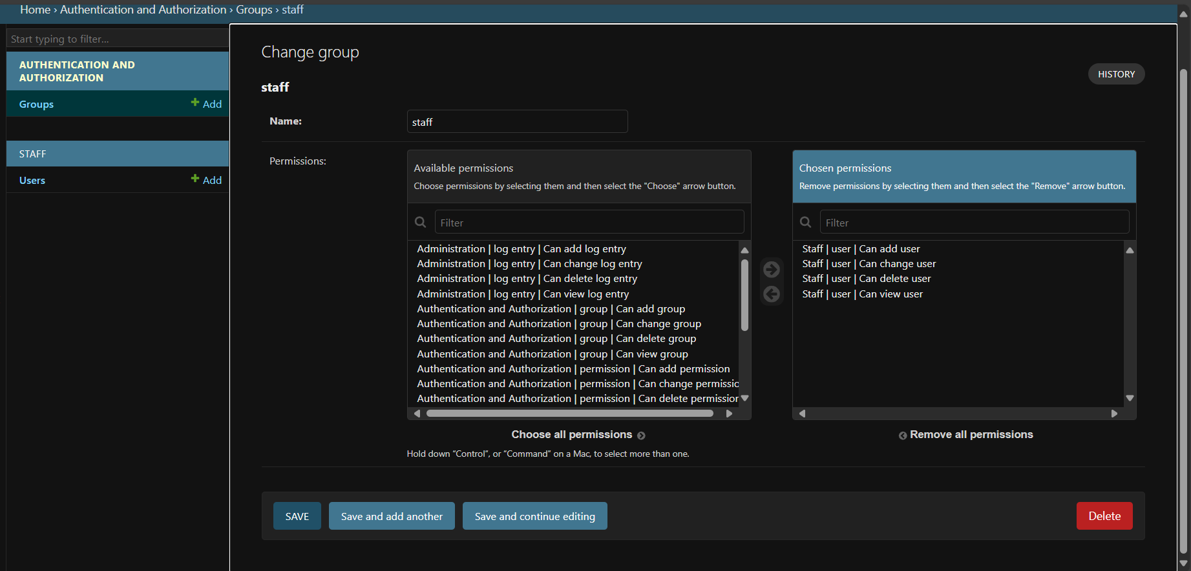
Restart Server(if changes don’t appear)
Create staff/signals.py
Create a signal to add staff users to the group
from django.db.models.signals import post_save
from django.dispatch import receiver
from django.contrib.auth.models import Group
from .models import User

@receiver(post_save, sender=User)
def add_user_to_staff_group(sender, instance, created, **kwargs):
# Define staff roles
staff_roles = ['manager', 'team_leader', 'team_member', 'trainee']

if instance.role in staff_roles:
# Get or create the 'staff' group
staff_group, _ = Group.objects.get_or_create(name='staff')

# Add user to the 'staff' group if not already in it
if not instance.groups.filter(name='staff').exists():
instance.groups.add(staff_group)

Why use signals?
- The permission assignment logic runs every time a user is created or updated, anywhere in your app.
- Keeps admin code clean and separates concerns.
- Works well with APIs, shell scripts, and admin.
Connect to staff/apps.py
from django.apps import AppConfig

class StaffConfig(AppConfig):
default_auto_field = 'django.db.models.BigAutoField'
name = 'staff'

def ready(self):
import staff.signals # noqa

Create users with roles

Folder Structure
CompanyProject/
│
├── CompanyProject/ # Main project directory
│ ├── __init__.py
│ ├── settings.py # Project settings
│ ├── urls.py # URL routing for the project
│ ├── wsgi.py # WSGI configuration
│ └── asgi.py # ASGI configuration
│
├── staff/ # Django app for user management
│ ├── migrations/ # Database migrations
│ │ └── __init__.py
│ ├── __init__.py
│ ├── admin.py # Admin interface customization
│ ├── apps.py # App configuration
│ ├── models.py # Data models (including custom user model)
│ ├── serializers.py # Serializers for API
│ ├── tests.py # Unit tests
│ ├── urls.py # URL routing for the staff app
│ ├── views.py # API views for user management
│ └── permissions.py # Custom permissions
│
├── db.sqlite3 # SQLite database file (if using SQLite)
├── manage.py # Command-line utility for administrative tasks
└── requirements.txt # List of project dependencies (optional)

Thank You

- Aditya Bhardwaj

